Task 1: Typical Home Wi-Fi Setup

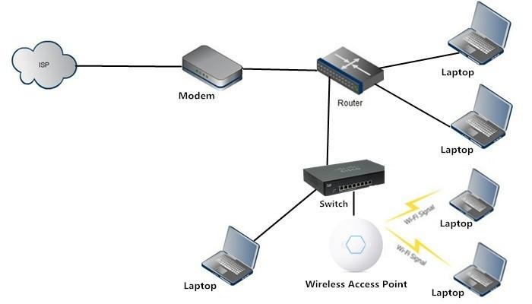
- Modem connects to the ISP line and plugs into the Router via Ethernet cable.
- Router connects to a Switch (for extra wired ports) and to an Access Point (for extending Wi-Fi range) it also connects directly to the laptop and desktop.
- A laptop and desktop connect via Ethernet cable to the Switch.
- A smartphone connects wirelessly to the Access Point or directly to the Router's Wi-Fi.

Task 2: Functions of Networking Hardware

- Modem (Modulator-Demodulator)
- Main Function: Converts analog signals from an Internet Service Provider (cable, DSL, or optical Fiber) into digital data that computers understand, and vice versa.
- Real-Life Example: The small box provided by an ISP (like Spectrum, Comcast, or Jio Fiber) located where the main utility line enters everyone’s house.
- Router
- Main Function: Manages network traffic between different networks (private local network and the public internet), assigns local IP addresses using DHCP, and enforces security with a firewall. Creates your local network, shares one internet connection across multiple devices, and usually broadcasts Wi-Fi
- Real-Life Example: A Wi-Fi router sitting in a living room that lets all family devices share one single internet connection.
- Network Switch
  - Main Function: Connects multiple wired devices together on the same local network (LAN) and uses hardware MAC addresses to send data packets directly to the destination device without collisions.
  - Real-Life Example: A small 8-port metal box under an office desk or entertainment console connecting a gaming PC, smart TV, and network printer with Ethernet cables.
- Access Point (AP)
  - Main Function: Connects to a wired router or switch via Ethernet and broadcasts a wireless radio frequency signal to provide or extend Wi-Fi coverage to client devices.
  - Real-Life Example: mounted on the ceiling in a large office or warehouse to cover the whole floor.
- Network Cable (Ethernet / Patch Cable)
  - Main Function: Provides a physical, interference-free transmission medium to carry electrical or light-based data signals between devices.
  - Real-Life Example: the cable running from your PC to your router/switch for a stable wired connection.

Task 3: Types of Network Cables

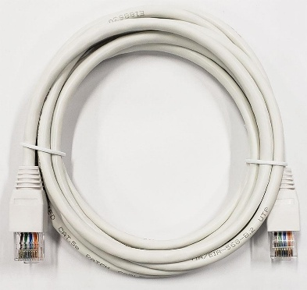
- Ethernet Cable (Twisted Pair): Ethernet cables such as
Cat5e/Cat6 are commonly used to connect computers,
routers, switches and other network devices in homes and offices.
Source: Wikimedia Commons – Cat 5e RJ45 Cable

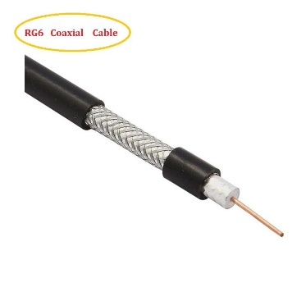

- Coaxial Cable: Coaxial cables are commonly used for cable
television, cable Internet and other RF signal connections.
Source: Wikimedia Commons – Coaxial Cable

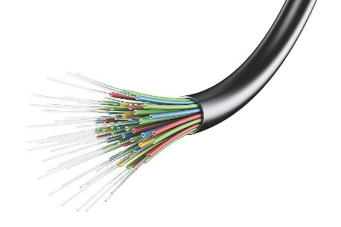

- Fiber optic cable: Used for high-speed, long-distance internet
backbones and modern fiber-to-the-home connections.
Source: https://en.wikipedia.org/wiki/Fiber-optic_cable
Task 4: Router vs Switch

Feature / Factor | Router | Network Switch
Main Use | Connects different networks together (e.g., Local Area Network to the Wide Area Network / Internet). | Connects multiple devices together within the same single Local Area Network (LAN).
Data Handling Method | Inspects IP addresses (Logical addressing) and routing information to determine where packets should go. | Inspects MAC addresses (Physical hardware addressing) to forward data frames directly to the target port.
OSI Model Layer | Operates primarily at Layer 3 (Network Layer). | Operates primarily at Layer 2 (Data Link Layer).
Typical Physical Location | Positioned at the network perimeter/boundary as the gateway between the home/office and the ISP modem. | Positioned internally within rooms, server closets, or wiring racks to expand available wired ports.
Network Services Provided | Runs DHCP (assigns IPs), NAT (Network Address Translation), and hardware firewall filters. | Does not assign IP addresses; acts as a passive, high-speed traffic director among connected devices.

